DIGITAL RESUME BUILDER AND JOB PORTAL
ABSTRACT:
The rapid advancement of Artificial Intelligence (AI), particularly Large Language Models (LLMs), has significantly transformed content generation tasks, including professional document creation such as resumes and cover letters. However, the effectiveness of AI-generated outputs heavily depends on the quality and structure of user inputs, commonly referred to as prompts. This paper explores the role of Prompt Engineering in enhancing AI-powered resume and cover letter writing systems. By designing structured, context-aware, and goal-oriented prompts, AI models can generate personalized, coherent, and industry-relevant documents tailored to specific job roles. The proposed approach integrates prompt templates, skill extraction, job description alignment, and iterative refinement techniques to improve accuracy and relevance. Experimental analysis demonstrates that prompt-engineered outputs outperform generic AI-generated content in terms of clarity, professionalism, and recruiter relevance. This study highlights prompt engineering as a critical layer in intelligent career-assistance systems, enabling scalable, efficient, and user-centric document generation.
INTRODUCTION:
In today’s competitive job market, resumes and cover letters play a crucial role in determining a candidate’s employability. Recruiters often spend only a few seconds reviewing each application, making clarity, relevance, and personalization essential. Traditional resume writing is time-consuming and requires strong language skills, domain knowledge, and awareness of Applicant Tracking Systems (ATS). As a result, many job seekers struggle to present their skills effectively.Artificial Intelligence, particularly Natural Language Processing (NLP) and Large Language Models such as GPT-based systems, has emerged as a powerful tool for automating professional document generation. AI-powered resume and cover letter writing systems can rapidly generate structured and grammatically correct content. However, without proper guidance, these systems often produce generic, repetitive, or misaligned outputs that fail to match specific job requirements.Prompt Engineering addresses this limitation by systematically designing and refining input instructions to guide AI models toward desired outcomes. In the context of resume and cover letter generation, prompt engineering enables the inclusion of job roles, skills, experience levels, achievements, tone preferences, and industry standards. Well-crafted prompts ensure that AI outputs are customized, concise, and relevant to the target position.This paper focuses on the application of prompt engineering techniques to improve AI-driven resume and cover letter writing. The study examines different prompt structures, contextual embeddings, and refinement strategies that enhance document quality. By incorporating job descriptions, keyword optimization, and iterative feedback, the proposed approach produces professional documents aligned with recruiter expectations and ATS requirements. The research demonstrates that prompt engineering is not merely an auxiliary step but a foundational component in building effective AI-powered career assistance systems.
OBJECTIVE
The main objective of the Resume and Cover Letter Generator project is to design and develop an intelligent system that assists users in creating professional and well-structured resumes and cover letters efficiently. The system aims to reduce the complexity involved in manual document creation by providing automated formatting, content suggestions, and customizable templates. It ensures that users can generate high-quality documents suitable for various job roles with minimal effort.

Another key objective is to incorporate Natural Language Processing (NLP) techniques to analyze user input and generate context-aware content for resumes and cover letters. The system will understand user skills, qualifications, and experiences to produce relevant and impactful descriptions. This enhances the personalization of documents, making them more appealing to recruiters and increasing the chances of job selection.
The project also aims to provide a user-friendly interface that allows individuals, including students and job seekers, to easily input their details and select preferred formats. It focuses on accessibility and simplicity so that even non-technical users can create professional documents without prior knowledge of resume writing. Additionally, the system will support multiple templates and formats to meet industry standards.
Finally, the objective is to integrate advanced features such as keyword optimization based on job descriptions, real-time preview, and downloadable formats like PDF and Word. This ensures that the generated resumes and cover letters are optimized for Applicant Tracking Systems (ATS) and modern recruitment processes. Overall, the project aims to bridge the gap between job seekers and employers by providing an efficient and smart document generation solution.
PROBLEM STATEMENT:
The increasing use of AI-based text generation tools for resume and cover letter writing has simplified document creation for job seekers. However, most existing AI systems generate generic, repetitive, and poorly customized content due to ineffective or unstructured user prompts. These outputs often fail to align with specific job descriptions, industry standards, and Applicant Tracking System (ATS) requirements.Additionally, many users lack the technical knowledge required to craft effective prompts, resulting in resumes and cover letters that do not accurately reflect their skills, experience, or career objectives. This limitation reduces the practical usefulness of AI tools and may negatively impact a candidate’s chances of selection.Therefore, there is a critical need for a prompt-engineering–driven framework that systematically guides AI models to generate personalized, relevant, and professional resumes and cover letters tailored to individual job roles and recruiter expectations.
EXISTING SYSTEM:
Current AI-powered resume and cover letter writing systems primarily rely on generic text generation models that accept minimal user input, such as job title, experience level, or a short description. These systems use pre-trained language models to generate content without structured guidance or deep contextual understanding.
Most existing platforms do not integrate systematic prompt engineering techniques. As a result, the AI produces standardized templates with limited personalization. The generated documents often lack alignment with specific job descriptions, recruiter expectations, and Applicant Tracking System (ATS) requirements. Additionally, these systems provide little or no feedback or refinement mechanism, making it difficult for users to improve the output quality.

DISADVANTAGES:
- Generic and repetitive content
- Limited personalization
- High dependency on user writing skills

PROPOSED SYSTEM:
The proposed system introduces a Prompt Engineering–driven AI framework for resume and cover letter generation. It employs structured, context-aware prompts that integrate user profile information, professional experience, skills, achievements, and target job descriptions.The system uses predefined prompt templates, dynamic keyword extraction, and iterative refinement strategies to guide the AI model toward producing tailored, professional, and ATS-friendly documents. By incorporating role-specific instructions and tone control, the system ensures that each output is customized for the intended job role. The framework can also support multiple iterations, allowing users to refine and improve the generated content efficiently.

ADVANATGES:
- Highly personalized resumes and cover letters
- Enhanced clarity, professionalism, and relevance
- Reduced time and effort

BLOCK DIAGRAME:
SYSTEM ARCHITECTURE
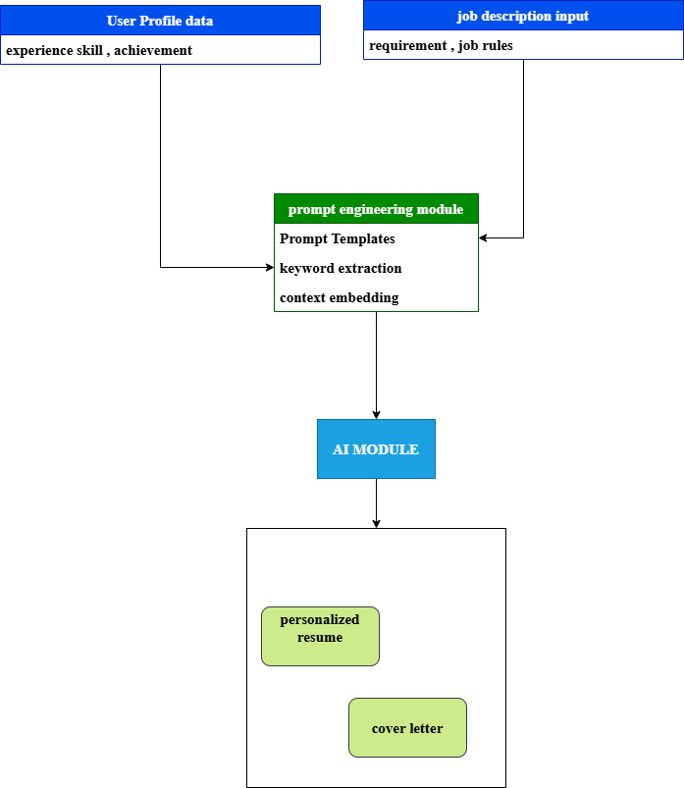

LITRETURE SURVEY
S.No | Year | Title | Author
1 | 2018 | Automated Resume Generation Using NLP Techniques | A. Sharma, R. Gupta
2 | 2019 | Intelligent Resume Builder with Machine Learning | K. Patel, S. Mehta
3 | 2020 | AI-Based Resume Screening and Ranking System | J. Brown, L. Smith
4 | 2020 | Natural Language Processing for Cover Letter Generation | M. Johnson, P. Lee
5 | 2021 | Smart Resume Analyzer Using Text Mining | R. Kumar, V. Singh
6 | 2021 | Automated Document Generation System Using AI | S. Verma, T. Rao
7 | 2022 | Resume Parsing and Job Matching Using Deep Learning | D. Chen, Y. Wang
8 | 2022 | AI-Powered Career Assistant for Resume Writing | N. Wilson, H. Taylor
9 | 2023 | Personalized Resume and Cover Letter Generator Using NLP | P. Das, A. Nair
10 | 2024 | ATS Optimization Techniques for Resume Enhancement | S. Iyer, K. Reddy

MODULES
- User Profile Data Module
- Job Description Input Module
- Data Preprocessing Module
- Prompt Engineering Module
- AI Processing Module
- Resume Generation Module
- Cover Letter Generation Module
- Personalization Module
- Template & Formatting Module
- Output Generation Module (PDF/Word Download)
User Profile Data Module
The User Profile Data Module is responsible for collecting and managing all personal and professional details required to generate a resume and cover letter. This includes information such as name, contact details, educational qualifications, work experience, technical skills, certifications, and achievements. The module ensures that the input data is structured and organized properly so that it can be effectively used by subsequent modules in the system. It also allows users to update or modify their information easily, making the system flexible and user-friendly. Data validation techniques are applied to ensure accuracy and completeness of the information provided by the user. This module acts as the foundation of the entire system, as the quality of the generated resume and cover letter largely depends on the correctness and richness of the user data collected at this stage.
Job Description Input Module
The Job Description Input Module allows users to provide details about the job role they are applying for. This may include job title, required skills, responsibilities, company details, and keywords mentioned in the job posting. The purpose of this module is to align the generated resume and cover letter with the specific requirements of the job. By analyzing the job description, the system can highlight relevant skills and experiences from the user’s profile. This module plays a crucial role in improving the chances of passing Applicant Tracking Systems (ATS), as it ensures that important keywords are included. It also helps in customizing the tone and content of the cover letter. Overall, this module bridges the gap between the user’s qualifications and the employer’s expectations, making the generated documents more targeted and effective.
Data Preprocessing Module
The Data Preprocessing Module is responsible for cleaning, organizing, and transforming the input data collected from both the user profile and job description modules. This includes removing unnecessary information, correcting grammatical errors, standardizing formats, and extracting key features such as skills, job roles, and achievements. Natural Language Processing (NLP) techniques may be used to tokenize, filter, and structure the text data. This module ensures that the data fed into the AI system is accurate, consistent, and meaningful. It also handles missing or incomplete data by applying appropriate techniques such as default values or user prompts. By refining the raw input data, this module improves the efficiency and accuracy of the AI model. Proper preprocessing is essential for generating high-quality, professional, and contextually relevant resumes and cover letters.
Prompt Engineering Module
The Prompt Engineering Module plays a vital role in guiding the AI system to generate accurate and context-aware outputs. It constructs well-structured prompts by combining user profile data and job description inputs in a meaningful way. These prompts are designed to instruct the AI model on how to generate resumes and cover letters that are relevant, concise, and professional. The module ensures that important details such as skills, experience, and job requirements are emphasized correctly. It may also include predefined templates or rules to maintain consistency in output. By carefully designing prompts, this module improves the quality of generated content and reduces errors or irrelevant information. It acts as a bridge between raw data and the AI model, ensuring that the input provided to the model is clear, specific, and optimized for best results.
AI Processing Module
The AI Processing Module is the core component of the system, where advanced algorithms and models are used to generate resumes and cover letters. This module utilizes techniques such as Natural Language Processing (NLP) and machine learning to understand the input data and produce meaningful outputs. The AI model analyzes the structured data and prompts to generate professional and customized content. It ensures that the generated text is grammatically correct, relevant, and aligned with industry standards. This module also adapts to different job roles and user profiles, making the output highly personalized. The efficiency of this module determines the overall performance of the system. By leveraging AI capabilities, this module automates the document creation process, saving time and effort for users while maintaining high-quality results.
Resume Generation Module
The Resume Generation Module is responsible for creating a structured and professional resume based on the processed data and AI-generated content. It organizes information into sections such as summary, education, skills, experience, and achievements. The module ensures that the resume follows standard formats and highlights the most relevant details according to the job description. It also focuses on clarity, readability, and proper formatting. The generated resume is tailored to match industry expectations and improve the chances of selection. This module may also allow customization options such as different layouts and styles. By combining user data with AI insights, the module produces a resume that effectively represents the candidate’s qualifications and strengths in a concise and impactful manner.
Cover Letter Generation Module
The Cover Letter Generation Module creates a personalized and professional cover letter based on the user’s profile and job description. It focuses on presenting the candidate’s motivation, skills, and suitability for the role in a compelling manner. The module ensures that the tone is formal and aligned with industry standards. It highlights key achievements and explains how the candidate can contribute to the organization. The generated cover letter is tailored to each job application, making it unique and relevant. This module also ensures proper structure, including introduction, body, and conclusion. By using AI-generated content, the module saves time and helps users create impactful cover letters that enhance their chances of getting shortlisted.
Personalization Module
The Personalization Module ensures that the generated resume and cover letter are tailored specifically to the user and the job role. It analyzes user data and job requirements to highlight relevant skills, experiences, and achievements. This module enhances the uniqueness of each document by avoiding generic content and focusing on individual strengths. It also adapts the tone, style, and structure based on the type of job and industry. Personalization improves the effectiveness of the documents by making them more relevant to recruiters. This module plays a crucial role in increasing user satisfaction and success rates. By combining AI insights with user-specific details, it ensures that each output is customized, professional, and aligned with the expectations of employers.
Template & Formatting Module
The Template and Formatting Module is responsible for designing the visual structure of resumes and cover letters. It provides various templates and layout options to suit different industries and user preferences. The module ensures proper alignment, font selection, spacing, and section organization. It maintains consistency and readability across all generated documents. Users can choose from different styles such as modern, professional, or creative formats. This module enhances the overall presentation and attractiveness of the documents. It also ensures compatibility with industry standards and Applicant Tracking Systems (ATS). By focusing on design and formatting, this module helps create visually appealing and well-structured documents that leave a positive impression on recruiters.
Output Generation Module (PDF/Word Download)
The Output Generation Module is responsible for converting the generated resume and cover letter into downloadable formats such as PDF and Word. It ensures that the final documents are properly formatted and ready for submission. The module maintains the layout, structure, and design consistency during the conversion process. It also provides options for previewing the documents before downloading. This module enhances user convenience by allowing easy sharing and printing of documents. It ensures compatibility across different platforms and devices. By providing high-quality output files, the module completes the document generation process effectively. It plays a crucial role in delivering the final product to the user in a professional and usable format.
UML DIAGRAMS
Level 0
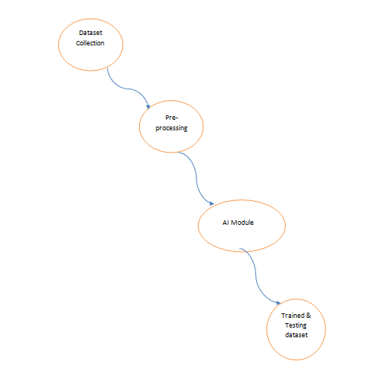
Level 1
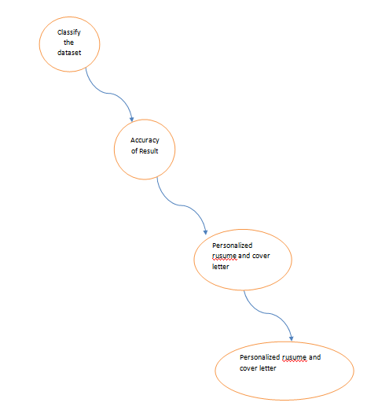
Use case diagram
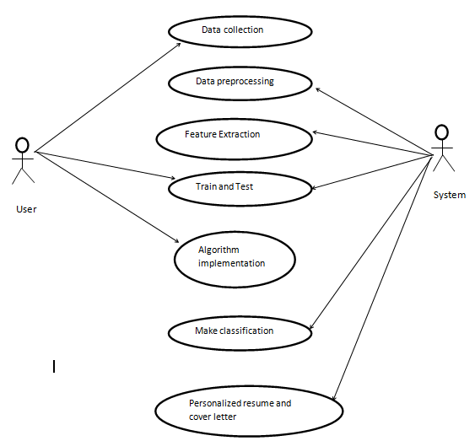
Sequence diagram
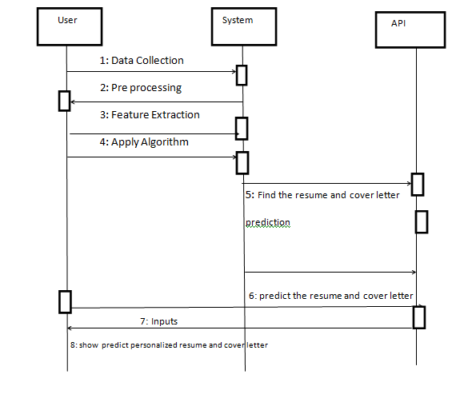
Activity diagram
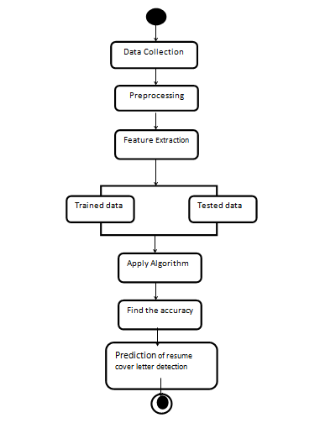
Collaboration diagram
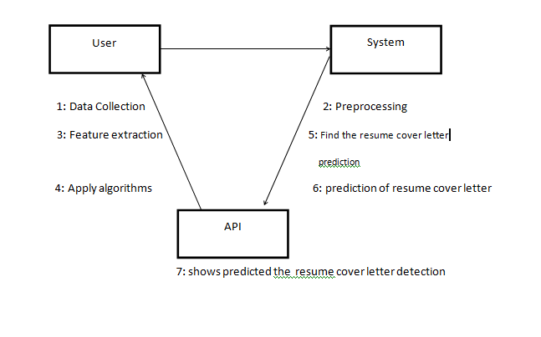
Class diagram
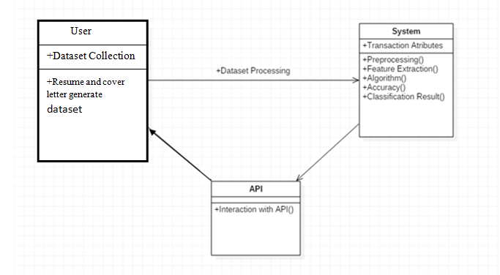
Use Case Diagram

The Use Case Diagram represents the interaction between users and the Resume and Cover Letter Generator system. The primary actor in this system is the user, who performs actions such as entering profile details, providing job descriptions, selecting templates, and generating documents. The system responds by processing the input, generating resumes and cover letters, and allowing users to download them. Additional use cases include editing user data, previewing documents, and customizing templates. The diagram helps in identifying the functional requirements of the system and shows how different components interact with the user. It simplifies the understanding of system behavior from an external perspective. By clearly defining user interactions, the use case diagram ensures that all necessary functionalities are covered, making the system user-centric and efficient in meeting user needs.
Sequence Diagram
The Sequence Diagram illustrates the step-by-step flow of interactions between different modules of the system over time. It begins with the user entering profile data and job description inputs through the interface. These inputs are then passed to the preprocessing module, where the data is cleaned and structured. The processed data is forwarded to the prompt engineering module, which prepares the input for the AI module. The AI module generates content for the resume and cover letter, which is then sent to the formatting module. Finally, the output module converts the content into downloadable formats like PDF or Word. The sequence diagram highlights the order of operations and communication between components, ensuring that the workflow is smooth and logical. It helps developers understand system behavior during execution and identify dependencies between modules.
Activity Diagram
The Activity Diagram represents the workflow and decision-making process involved in generating resumes and cover letters. It starts with the user entering profile information and job description details. The system then performs data validation and preprocessing. Based on the completeness of the data, the flow may proceed or request additional input from the user. Once validated, the prompt engineering module constructs input for the AI system. The AI module generates the required content, which is then formatted into structured documents. The user is given an option to preview and edit the documents before finalizing them. After confirmation, the documents are converted into downloadable formats. The activity diagram clearly shows the flow of control, parallel processes, and decision points within the system. It helps in understanding the dynamic aspects of the system and ensures efficient workflow design.
Collaboration Diagram
The Collaboration Diagram (also known as a Communication Diagram) focuses on the interaction between different components of the system and how they collaborate to achieve the desired output. In this project, modules such as user input, preprocessing, prompt engineering, AI processing, and output generation work together in a coordinated manner. The user initiates the process by providing input, which is then shared across modules. Each module performs a specific function and passes the result to the next module. The diagram emphasizes the relationships and message flow between components rather than the sequence of operations. It helps in understanding how different parts of the system communicate and depend on each other. By visualizing these interactions, developers can design a more efficient and modular system architecture.
Class Diagram
The Class Diagram represents the static structure of the system by showing different classes, their attributes, methods, and relationships. In this project, classes may include User, JobDescription, Resume, CoverLetter, AIEngine, Template, and OutputGenerator. Each class contains attributes such as user details, job requirements, and document content, along with methods for processing and generating outputs. Relationships such as association, inheritance, and dependency are used to connect these classes. For example, the User class is associated with Resume and CoverLetter classes, while the AIEngine class processes data from multiple sources. The class diagram helps in designing the system architecture and organizing code efficiently. It provides a clear blueprint for developers to implement the system, ensuring maintainability, scalability, and proper object-oriented design principles.
Domain Specification
DIGITAL IMAGE PROCESSING
The identification of objects in an image and this process would probably start with image processing techniques such as noise removal, followed by (low-level) feature extraction to locate lines, regions and possibly areas with certain textures.
The clever bit is to interpret collections of these shapes as single objects, e.g. cars on a road, boxes on a conveyor belt or cancerous cells on a microscope slide. One reason this is an AI problem is that an object can appear very different when viewed from different angles or under different lighting. Another problem is deciding what features belong to what object and which are background or shadows etc. The human visual system performs these tasks mostly unconsciously but a computer requires skilful programming and lots of processing power to approach human performance. Manipulation of data in the form of an image through several possible techniques. An image is usually interpreted as a two-dimensional array of brightness values, and is most familiarly represented by such patterns as those of a photographic print, slide, television screen, or movie screen. An image can be processed optically or digitally with a computer.

- Basics of Image Processing:-

FUNDAMENTALS OF DIGITAL IMAGE

1.1 IMAGE:
An image is a two-dimensional picture, which has a similar appearance to some subject usually a physical object or a person.

Image is a two-dimensional, such as a photograph, screen display, and as well as a three-dimensional, such as a statue. They may be captured by optical devices—such as cameras, mirrors, lenses, telescopes, microscopes, etc. and natural objects and phenomena, such as the human eye or water surfaces.

The word image is also used in the broader sense of any two-dimensional figure such as a map, a graph, a pie chart, or an abstract painting. In this wider sense, images can also be rendered manually, such as by drawing, painting, carving, rendered automatically by printing or computer graphics technology, or developed by a combination of methods, especially in a pseudo-photograph.


Fig: Colour image to Gray scale Conversion Process

An image is a rectangular grid of pixels. It has a definite height and a definite width counted in pixels. Each pixel is square and has a fixed size on a given display. However different computer monitors may use different sized pixels. The pixels that constitute an image are ordered as a grid (columns and rows); each pixel consists of numbers representing magnitudes of brightness and color.
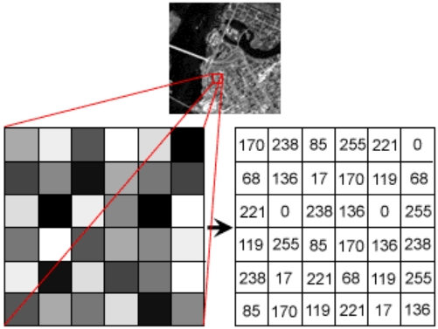
Fig: Gray Scale Image Pixel Value Analysis
Each pixel has a color. The color is a 32-bit integer. The first eight bits determine the redness of the pixel, the next eight bits the greenness, the next eight bits the blueness, and the remaining eight bits the transparency of the pixel.
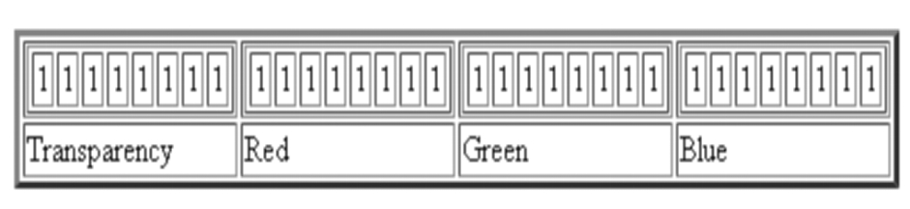
Fig: BIT Transferred for Red, Green and Blue plane (24bit=8bit red;8-bit green;8bit blue)
IMAGE FILE SIZES:
Image file size is expressed as the number of bytes that increases with the number of pixels composing an image, and the color depth of the pixels. The greater the number of rows and columns, the greater the image resolution, and the larger the file. Also, each pixel of an image increases in size when its color depth increases, an 8-bit pixel (1 byte) stores 256 colors, a 24-bit pixel (3 bytes) stores 16 million colors, the latter known as true color.Image compression uses algorithms to decrease the size of a file. High resolution cameras produce large image files, ranging from hundreds of kilobytes to megabytes, per the camera's resolution and the image-storage format capacity. High resolution digital cameras record 12 megapixel (1MP = 1,000,000 pixels / 1 million) images, or more, in true color. For example, an image recorded by a 12 MP camera; since each pixel uses 3 bytes to record true color, the uncompressed image would occupy 36,000,000 bytes of memory, a great amount of digital storage for one image, given that cameras must record and store many images to be practical. Faced with large file sizes, both within the camera and a storage disc, image file formats were developed to store such large images.
IMAGE FILE FORMATS:
Image file formats are standardized means of organizing and storing images. This entry is about digital image formats used to store photographic and other images. Image files are composed of either pixel or vector (geometric) data that are rasterized to pixels when displayed (with few exceptions) in a vector graphic display. Including proprietary types, there are hundreds of image file types. The PNG, JPEG, and GIF formats are most often used to display images on the Internet.
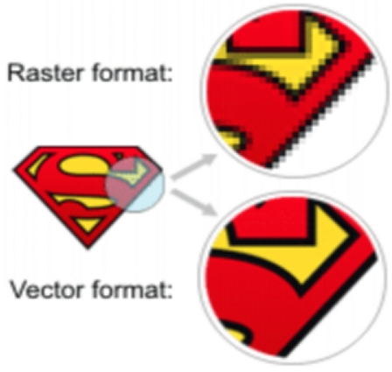
Fig: Horizontal and Vertical Process
In addition to straight image formats, Metafile formats are portable formats which can include both raster and vector information. The metafile format is an intermediate format. Most Windows applications open metafiles and then save them in their own native format.
IMAGE PROCESSING:
Digital image processing, the manipulation of images by computer, is relatively recent development in terms of man’s ancient fascination with visual stimuli. In its short history, it has been applied to practically every type of images with varying degree of success. The inherent subjective appeal of pictorial displays attracts perhaps a disproportionate amount of attention from the scientists and also from the layman. Digital image processing like other glamour fields, suffers from myths, mis-connect ions, mis-understandings and mis-information. It is vast umbrella under which fall diverse aspect of optics, electronics, mathematics, photography graphics and computer technology. It is truly multidisciplinary endeavor ploughed with imprecise jargon.
Several factor combine to indicate a lively future for digital image processing. A major factor is the declining cost of computer equipment. Several new technological trends promise to further promote digital image processing. These include parallel processing mode practical by low cost microprocessors, and the use of charge coupled devices (CCDs) for digitizing, storage during processing and display and large low cost of image storage arrays.
FUNDAMENTAL STEPS IN DIGITAL IMAGE PROCESSING:
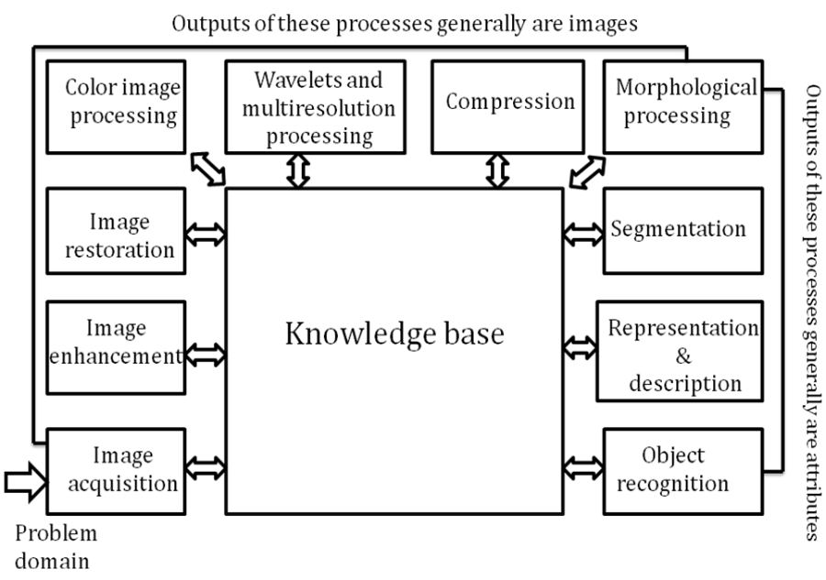Fig: Basics steps of image Processing

Image Acquisition:
Image Acquisition is to acquire a digital image. To do so requires an image sensor and the capability to digitize the signal produced by the sensor. The sensor could be monochrome or color TV camera that produces an entire image of the problem domain every 1/30 sec. the image sensor could also be line scan camera that produces a single image line at a time. In this case, the objects motion past the line.
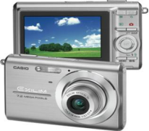
Fig: Digital camera
Scanner produces a two-dimensional image. If the output of the camera or other imaging sensor is not in digital form, an analog to digital converter digitizes it. The nature of the sensor and the image it produces are determined by the application.
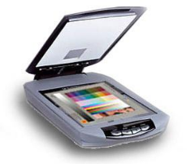
Fig: Mobile based Camera
Image Enhancement:

Image enhancement is among the simplest and most appealing areas of digital image processing. Basically, the idea behind enhancement techniques is to bring out detail that is obscured, or simply to highlight certain features of interesting an image. A familiar example of enhancement is when we increase the contrast of an image because “it looks better.” It is important to keep in mind that enhancement is a very subjective area of image processing.


Fig: Image enhancement process for Gray Scale Image and Colour Image using Histogram Bits

1.5.3 Image restoration:

Image restoration is an area that also deals with improving the appearance of an image. However, unlike enhancement, which is subjective, image restoration is objective, in the sense that restoration techniques tend to be based on mathematical or probabilistic models of image degradation.

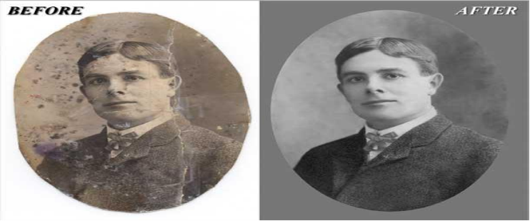
Fig: Noise image🡪 Image Enhancement

Enhancement, on the other hand, is based on human subjective preferences regarding what constitutes a “good” enhancement result. For example, contrast stretching is considered an enhancement technique because it is based primarily on the pleasing aspects it might present to the viewer, where as removal of image blur by applying a deblurring function is considered a restoration technique.

Color image processing:

The use of color in image processing is motivated by two principal factors. First, color is a powerful descriptor that often simplifies object identification and extraction from a scene. Second, humans can discern thousands of color shades and intensities, compared to about only two dozen shades of gray. This second factor is particularly important in manual image analysis.


Fig: gray Scale image 🡪 Colour Image

Segmentation:

Segmentation procedures partition an image into its constituent parts or objects. In general, autonomous segmentation is one of the most difficult tasks in digital image processing. A rugged segmentation procedure brings the process a long way toward successful solution of imaging problems that require objects to be identified individually.

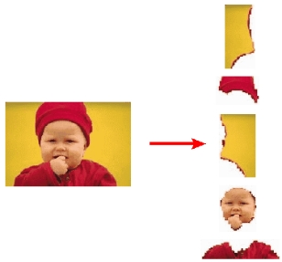
Fig: Image Segment Process

On the other hand, weak or erratic segmentation algorithms almost always guarantee eventual failure. In general, the more accurate the segmentation, the more likely recognition is to succeed.
Digital image is defined as a two dimensional function f(x, y), where x and y are spatial (plane) coordinates, and the amplitude of f at any pair of coordinates (x, y) is called intensity or grey level of the image at that point. The field of digital image processing refers to processing digital images by means of a digital computer. The digital image is composed of a finite number of elements, each of which has a particular location and value. The elements are referred to as picture elements, image elements, pels, and pixels. Pixel is the term most widely used.
Image Compression

Digital Image compression addresses the problem of reducing the amount of data required to represent a digital image. The underlying basis of the reduction process is removal of redundant data. From the mathematical viewpoint, this amounts to transforming a 2D pixel array into a statically uncorrelated data set. The data redundancy is not an abstract concept but a mathematically quantifiable entity. If n1 and n2 denote the number of information-carrying units in two data sets that represent the same information, the relative data redundancy 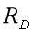 [2] of the first data set (the one characterized by n1) can be defined as,
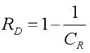
Where  called as compression ratio [2]. It is defined as
= 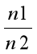
In image compression, three basic data redundancies can be identified and exploited: Coding redundancy, interpixel redundancy, and phychovisal redundancy. Image compression is achieved when one or more of these redundancies are reduced or eliminated. The image compression is mainly used for image transmission and storage. Image transmission applications are in broadcast television; remote sensing via satellite, air-craft, radar, or sonar; teleconferencing; computer communications; and facsimile transmission. Image storage is required most commonly for educational and business documents, medical images that arise in computer tomography (CT), magnetic resonance imaging (MRI) and digital radiology, motion pictures, satellite images, weather maps, geological surveys, and so on.
Image Compression Model
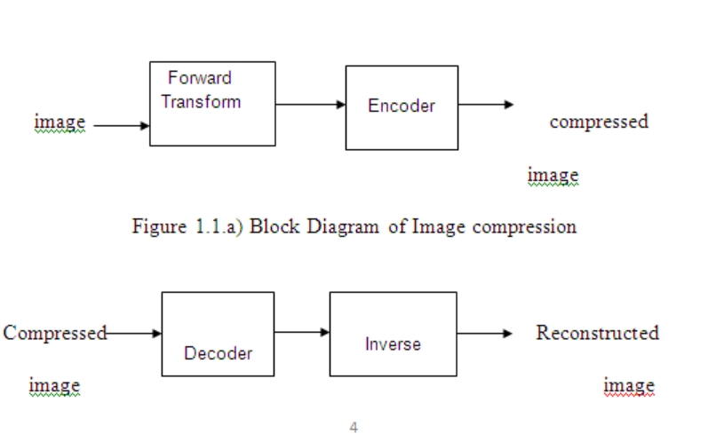
Fig:1.1b) Decompression Process for Image
Image Compression Types
There are two types’ image compression techniques.
1. Lossy Image compression
2. Lossless Image compression
Compression ratio:
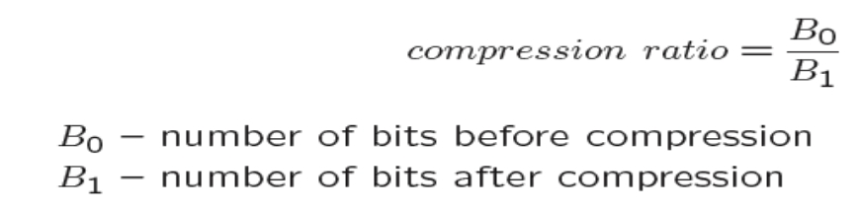
1. Lossy Image compression :
Lossy compression provides higher levels of data reduction but result in a less than perfect reproduction of the original image. It provides high compression ratio. lossy image compression is useful in applications such as broadcast television, videoconferencing, and facsimile transmission, in which a certain amount of error is an acceptable trade-off for increased compression performance. Originally, PGF has been designed to quickly and progressively decode lossy compressed aerial images. A lossy compression mode has been preferred, because in an application like a terrain explorer texture data (e.g., aerial orthophotos) is usually mid-mapped filtered and therefore lossy mapped onto the terrain surface. In addition, decoding lossy compressed images is usually faster than decoding lossless compressed images.
In the next test series we evaluate the lossy compression efficiency of PGF. One of the best competitors in this area is for sure JPEG 2000. Since JPEG 2000 has two different filters, we used the one with the better trade-off between compression efficiency and runtime. On our machine the 5/3 filter set has a better trade-off than the other. However, JPEG 2000 has in both cases a remarkable good compression efficiency for very high compression ratios but also a very poor encoding and decoding speed. The other competitor is JPEG. JPEG is one of the most popular image file formats.

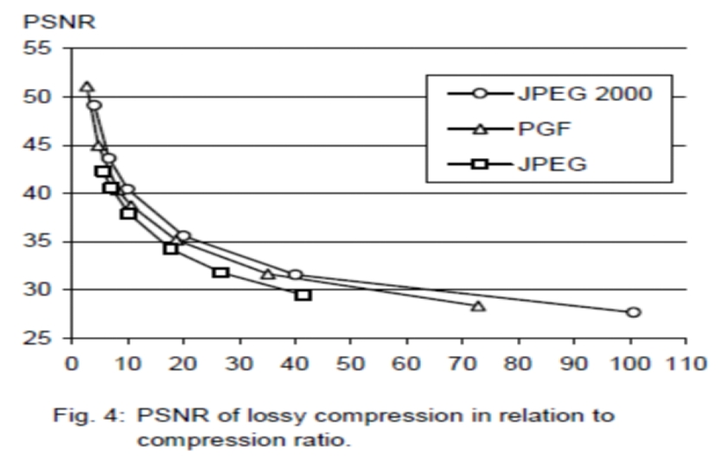
It is very fast and has a reasonably good compression efficiency for a wide range of compression ratios. The drawbacks of JPEG are the missing lossless compression and the often missing progressive decoding. Fig. 4 depicts the average rate-distortion behavior for the images in the Kodak test set when fixed (i.e., nonprogressive) lossy compression is used. The PSNR of PGF is on average 3% smaller than the PSNR of JPEG 2000, but 3% better than JPEG.
These results are also qualitative valid for our PGF test set and they are characteristic for aerial ortho-photos and natural images. Because of the design of PGF we already know that PGF does not reach the compression efficiency of JPEG 2000. However, we are interested in the trade-off between compression efficiency and runtime. To report this trade-off we show in Table 4 a comparison between JPEG 2000 and PGF and in Fig. 5 (on page 8) we show for the same test series as in Fig. 4 the corresponding average decoding times in relation to compression ratios.Table 4 contains for seven different compression ratios (mean values over the compression ratios of the eight images of the Kodak test set) the corresponding average encoding and decoding times in relation to the average PSNR values. In case of PGF the encoding time is always slightly longer than the corresponding decoding time. The reason for that is that the actual encoding phase (cf. Subsection 2.4.2) takes slightly longer than the corresponding decoding phase. For six of seven ratios the PSNR difference between JPEG 2000 and PGF is within 3% of the PSNR of JPEG 2000. Only in the first row is the difference larger (21%), but because a PSNR of 50 corresponds to an almost perfect image quality the large PSNR difference corresponds with an almost undiscoverable visual difference. The price they pay in JPEG 2000 for the 3% more PSNR is very high. The creation of a PGF is five to twenty times faster than the creation of a corresponding JPEG 2000 file, and the decoding of the created PGF is still five to ten times faster than the decoding of the JPEG 2000 file. This gain in speed is remarkable, especially in areas where time is more important than quality, maybe for instance in real-time computation.
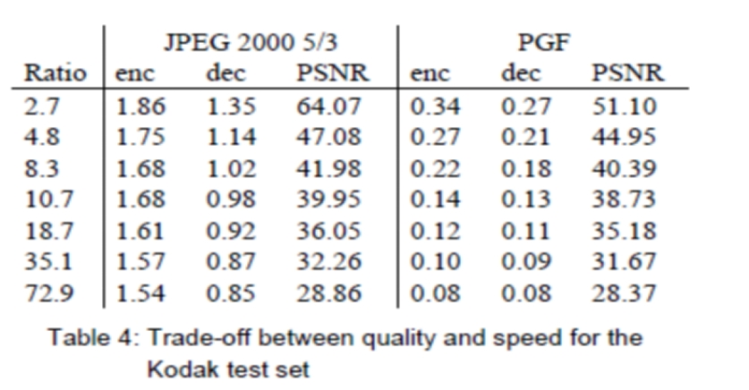
In Fig. 5 we see that the price we pay in PGF for the 3% more PSNR than JPEG is low: for small compression ratios (< 9) decoding in PGF takes two times longer than JPEG and for higher compression ratios (> 30) it takes only ten percent longer than JPEG. These test results are characteristic for both natural images and aerial ortho-photos. Again, in the third test series we only use the ‘Lena’ image. We run our lossy coder with six different quantization parameters and measure the PSNR in relation to the resulting compression ratios. The results (ratio: PSNR) are:
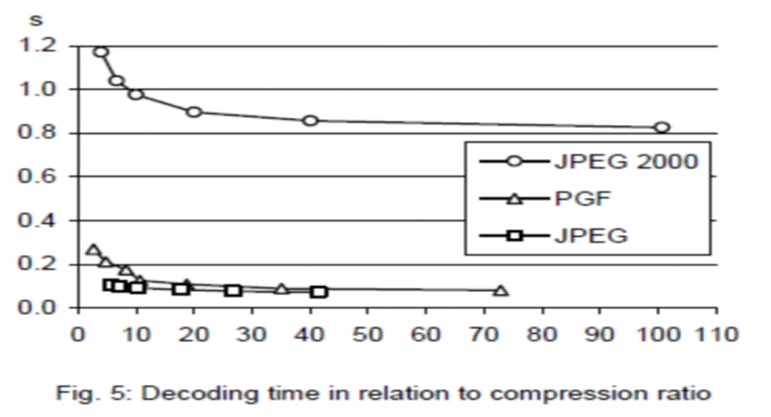

2.Lossless Image compression :
Lossless Image compression is the only acceptable amount of data reduction. It provides low compression ratio while compared to lossy. In Lossless Image compression techniques are composed of two relatively independent operations: (1) devising an alternative representation of the image in which its interpixel redundancies are reduced and (2) coding the representation to eliminate coding redundancies.
Lossless Image compression is useful in applications such as medical imaginary, business documents and satellite images.Table 2 summarizes the lossless compression efficiency and Table 3 the coding times of the PGF test set. For WinZip we only provide average runtime values, because of missing source code we have to use an interactive testing procedure with runtimes measured by hand. All other values are measured in batch mode.
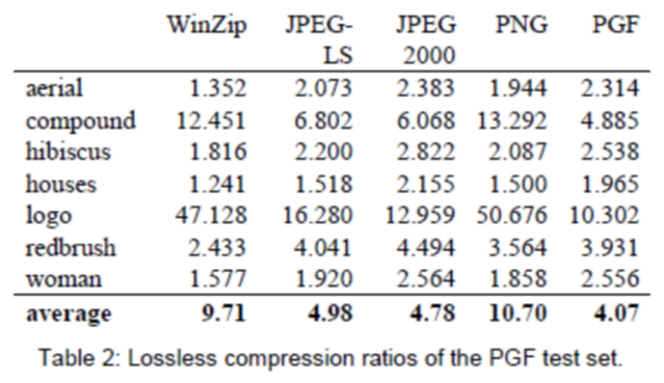
In Table 2 it can be seen that in almost all cases the best compression ratio is obtained by JPEG 2000, followed by PGF, JPEG-LS, and PNG. This result is different to the result in [SEA+00], where the best performance for a similar test set has been reported for JPEG-LS. PGF performs between 0.5% (woman) and 21.3% (logo) worse than JPEG 2000. On average it is almost 15% worse. The two exceptions to the general trend are the ‘compound’ and the ‘logo’ images. Both images contain for the most part black text on a white background. For this type of images, JPEG-LS and in particular WinZip and PNG provide much larger compression ratios. However, in average PNG performs the best, which is also reported in [SEA+00].
These results show, that as far as lossless compression is concerned, PGF performs reasonably well on natural and aerial images. In specific types of images such as ‘compound’ and ‘logo’ PGF is outperformed by far in PNG.
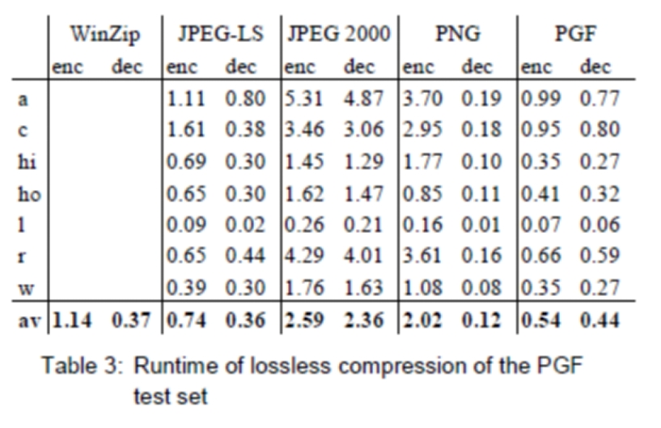
Table 3 shows the encoding (enc) and decoding (dec) times (measured in seconds) for the same algorithms and images as in Table 2. JPEG 2000 and PGF are both symmetric algorithms, while WinZip, JPEG-LS and in particular PNG are asymmetric with a clearly shorter decoding than encoding time. JPEG 2000, the slowest in encoding and decoding, takes more than four times longer than PGF. This speed gain is due to the simpler coding phase of PGF. JPEG-LS is slightly slower than PGF during encoding, but slightly faster in decoding images.
WinZip and PNG decode even more faster than JPEG-LS, but their encoding times are also worse. PGF seems to be the best compromise between encoding and decoding times.

Our PGF test set clearly shows that PGF in lossless mode is best suited for natural images and aerial ortho photos. PGF is the only algorithm that encodes the three Mega Byte large aerial ortho photo in less than second without a real loss of compression efficiency. For this particular image the efficiency loss is less than three percent compared to the best. These results should be underlined with our second test set, the Kodak test set.

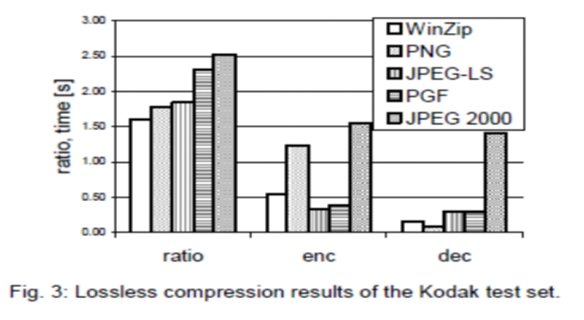
Fig. 3 shows the averages of the compression ratios (ratio), encoding (enc), and decoding (dec) times over all eight images. JPEG 2000 shows in this test set the best compression efficiency followed by PGF, JPEG-LS, PNG, and WinZip. In average PGF is eight percent worse than JPEG 2000. The fact that JPEG 2000 has a better lossless compression ratio than PGF does not surprise,
because JPEG 2000 is more quality driven than PGF.

However, it is remarkable that PGF is clearly better than JPEG-LS (+21%) and PNG (+23%) for natural images. JPEG-LS shows in the Kodak test set also a symmetric encoding and decoding time behaviour. It is encoding and decoding times are almost equal to PGF. Only PNG and WinZip can faster decode than PGF, but they also take longer than PGF to encode.
If both compression efficiency and runtime is important, then PGF is clearly the best of the tested algorithms for lossless compression of natural images and aerial ortho photos. In the third test we perform our lossless coder on the ‘Lena’ image.
To digitally process an image, it is first necessary to reduce the image to a series of numbers that can be manipulated by the computer. Each number representing the brightness value of the image at a particular location is called a picture element, or pixel. A typical digitized image may have 512 × 512 or roughly 250,000 pixels, although much larger images are becoming common. Once the image has been digitized, there are three basic operations that can be performed on it in the computer. For a point operation, a pixel value in the output image depends on a single pixel value in the input image. For local operations, several neighbouring pixels in the input image determine the value of an output image pixel. In a global operation, all of the input image pixels contribute to an output image pixel value.
Correspondingly, these combinations attempt to strike a winning tradeoff: be flexible and hence bring tolerance toward intraclass variation, while also being discriminative enough to be robust to background clutter and interclass similarity. An important feature of our contour-based recognition approach is that it affords us substantial flexibility to incorporate additional image information. Specifically, we extend the contour-based recognition method and propose a new hybrid recognition method which exploits shape tokens and SIFT features as recognition cues. Shape-tokens and SIFT features are largely orthogonal, where the former corresponds to shape boundaries and the latter to sparse salient image patches. Here, each learned combination can comprise features that are either 1) purely shape-tokens, 2) purely SIFT features, or 3) a mixture of shape-tokens and SIFT features. The number and types of features to be combined together are learned automatically from training images, and represent the more discriminative ones based on the training set. Consequently, by imparting these two degrees of variability (in both the number and the types of features) to a combination, we empower it with even greater flexibility and discriminative potential. A shorter version of this paper appeared in [9].

CLASSIFICATION OF IMAGES:

There are 3 types of images used in Digital Image Processing. They are

- Binary Image
- Gray Scale Image
- Colour Image

BINARY IMAGE:

A binary image is a digital image that has only two possible values for each pixel. Typically the two colors used for a binary image are black and white though any two colors can be used. The color used for the object(s) in the image is the foreground color while the rest of the image is the background color.
Binary images are also called bi-level or two-level. This means that each pixel is stored as a single bit (0 or 1).This name black and white, monochrome or monochromatic are often used for this concept, but may also designate any images that have only one sample per pixel, such as grayscale images
Binary images often arise in digital image processing as masks or as the result of certain operations such as segmentation, thresholding, and dithering. Some input/output devices, such as laser printers, fax machines, and bi-level computer displays, can only handle bi-level images
GRAY SCALE IMAGE
A grayscale Image is digital image is an image in which the value of each pixel is a single sample, that is, it carries only intensity information. Images of this sort, also known as black-and-white, are composed exclusively of shades of gray(0-255), varying from black(0) at the weakest intensity to white(255) at the strongest.
Grayscale images are distinct from one-bit black-and-white images, which in the context of computer imaging are images with only the two colors, black, and white (also called bi-level or binary images). Grayscale images have many shades of gray in between. Grayscale images are also called monochromatic, denoting the absence of any chromatic variation.
Grayscale images are often the result of measuring the intensity of light at each pixel in a single band of the electromagnetic spectrum (e.g. infrared, visible light, ultraviolet, etc.), and in such cases they are monochromatic proper when only a given frequency is captured. But also they can be synthesized from a full color image; see the section about converting to grayscale.
COLOUR IMAGE:
A (digital) color image is a digital image that includes color information for each pixel. Each pixel has a particular value which determines its appearing color. This value is qualified by three numbers giving the decomposition of the color in the three primary colors Red, Green and Blue. Any color visible to human eye can be represented this way. The decomposition of a color in the three primary colors is quantified by a number between 0 and 255. For example, white will be coded as R = 255, G = 255, B = 255; black will be known as (R,G,B) = (0,0,0); and say, bright pink will be : (255,0,255).
In other words, an image is an enormous two-dimensional array of color values, pixels, each of them coded on 3 bytes, representing the three primary colors. This allows the image to contain a total of 256x256x256 = 16.8 million different colors. This technique is also known as RGB encoding, and is specifically adapted to human vision

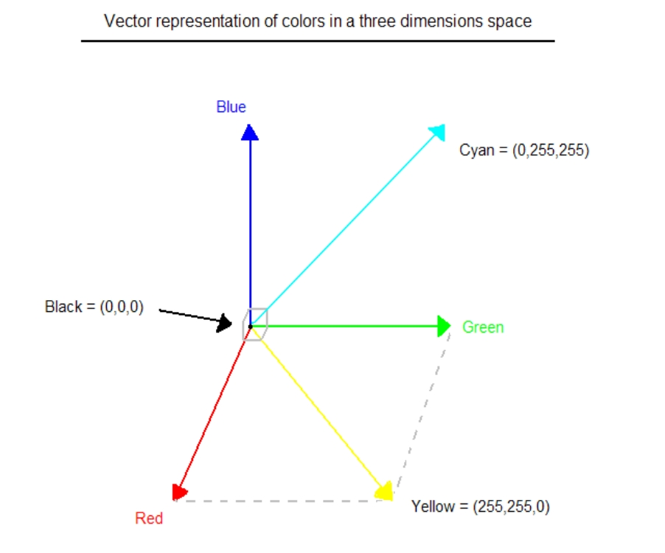
Fig.1 Hue Saturation Process of RGB SCALE Image
From the above figure, colors are coded on three bytes representing their decomposition on the three primary colors. It sounds obvious to a mathematician to immediately interpret colors as vectors in a three dimension space where each axis stands for one of the primary colors. Therefore we will benefit of most of the geometric mathematical concepts to deal with our colors, such as norms, scalar product, projection, rotation or distance.

PYTHON OVERVIEW
Python is a high-level, interpreted, interactive and object-oriented scripting language. Python is designed to be highly readable. It uses English keywords frequently where as other languages use punctuation, and it has fewer syntactical constructions than other languages.

- Python is Interpreted: Python is processed at runtime by the interpreter. You do not need to compile your program before executing it. This is similar to PERL and PHP.

- Python is Interactive: You can actually sit at a Python prompt and interact with the interpreter directly to write your programs.

- Python is Object-Oriented: Python supports Object-Oriented style or technique of programming that encapsulates code within objects.

- Python is a Beginner's Language: Python is a great language for the beginner-level programmers and supports the development of a wide range of applications from simple text processing to WWW browsers to games.

History of Python

Python was developed by Guido van Rossum in the late eighties and early nineties at the National Research Institute for Mathematics and Computer Science in the Netherlands.

Python is derived from many other languages, including ABC, Modula-3, C, C++, Algol-68, SmallTalk, Unix shell, and other scripting languages.

Python is copyrighted. Like Perl, Python source code is now available under the GNU General Public License (GPL).

Python is now maintained by a core development team at the institute, although Guido van Rossum still holds a vital role in directing its progress.

Python Features

Python's features include:

- Easy-to-learn: Python has few keywords, simple structure, and a clearly defined syntax. This allows the student to pick up the language quickly.

- Easy-to-read: Python code is more clearly defined and visible to the eyes.

- Easy-to-maintain: Python's source code is fairly easy-to-maintain.

- A broad standard library: Python's bulk of the library is very portable and cross-platform compatible on UNIX, Windows, and Macintosh.

- Interactive Mode: Python has support for an interactive mode which allows interactive testing and debugging of snippets of code.

- Portable: Python can run on a wide variety of hardware platforms and has the same interface on all platforms.

- Extendable: You can add low-level modules to the Python interpreter. These modules enable programmers to add to or customize their tools to be more efficient.

- Databases: Python provides interfaces to all major commercial databases.

- GUI Programming: Python supports GUI applications that can be created and ported to many system calls, libraries, and windows systems, such as Windows MFC, Macintosh, and the X Window system of Unix.

- Scalable: Python provides a better structure and support for large programs than shell scripting.

Apart from the above-mentioned features, Python has a big list of good features, few are listed below:

- IT supports functional and structured programming methods as well as OOP.

- It can be used as a scripting language or can be compiled to byte-code for building large applications.

- It provides very high-level dynamic data types and supports dynamic type checking.

- IT supports automatic garbage collection.

- It can be easily integrated with C, C++, COM, ActiveX, CORBA, and Java.

Python is available on a wide variety of platforms including Linux and Mac OS X. Let's understand how to set up our Python environment.

ANACONDA NAVIGATOR

Anaconda Navigator is a desktop graphical user interface (GUI) included in Anaconda distribution that allows you to launch applications and easily manage conda packages, environments and channels without using command-line commands. Navigator can search for packages on Anaconda Cloud or in a local Anaconda Repository. It is available for Windows, mac OS and Linux.

Why use Navigator?
In order to run, many scientific packages depend on specific versions of other packages. Data scientists often use multiple versions of many packages, and use multiple environments to separate these different versions.
The command line program conda is both a package manager and an environment manager, to help data scientists ensure that each version of each package has all the dependencies it requires and works correctly.
Navigator is an easy, point-and-click way to work with packages and environments without needing to type conda commands in a terminal window. You can use it to find the packages you want, install them in an environment, run the packages and update them, all inside Navigator.

WHAT APPLICATIONS CAN I ACCESS USING NAVIGATOR?
The following applications are available by default in Navigator:
- Jupyter Lab
- Jupyter Notebook
- QT Console
- Spyder
- VS Code
- Glue viz
- Orange 3 App
- Rodeo
- RStudio
Advanced conda users can also build your own Navigator applications

How can I run code with Navigator?
The simplest way is with Spyder. From the Navigator Home tab, click Spyder, and write and execute your code.
You can also use Jupyter Notebooks the same way. Jupyter Notebooks are an increasingly popular system that combine your code, descriptive text, output, images and interactive interfaces into a single notebook file that is edited, viewed and used in a web browser.

What’s new in 1.9?
- Add support for Offline Mode for all environment related actions.
- Add support for custom configuration of main windows links.
- Numerous bug fixes and performance enhancements.

TESTING

Software testing is an investigation conducted to provide stakeholders with information about the quality of the product or service under test. Software Testing also provides an objective, independent view of the software to allow the business to appreciate and understand the risks at implementation of the software. Test techniques include, but are not limited to, the process of executing a program or application with the intent of finding software bugs.
Software Testing can also be stated as the process of validating and verifying that a software program/application/product:
- Meets the business and technical requirements that guided its design and Development.
- Works as expected and can be implemented with the same characteristics.

TESTING METHODS

- Functional Testing

Functional tests provide systematic demonstrations that functions tested are available as specified by the business and technical requirements, system documentation, and user manuals.
Functional testing is centered on the following items:
- Functions: Identified functions must be exercised.
- Output: Identified classes of software outputs must be exercised.
- Systems/Procedures: system should work properly

Integration Testing

Software integration testing is the incremental integration testing of two or more integrated software components on a single platform to produce failures caused by interface defects.

Test Case for Excel Sheet Verification:

Here in machine learning we are dealing with dataset which is in excel sheet format so if any test case we need means we need to check excel file. Later on classification will work on the respective columns of dataset .
SOFTWARE REQUIREMENTS
- Python idle
- Anaconda prompt
- opencv

HARDWARE REQUIREMENTS

1)Operating System : Windows Only
2)Processor : i5 and above
3)Ram : 4gb and above
4)Hard Disk : 50 GB

CONCLUSION
The Resume and Cover Letter Generator project provides an efficient and intelligent solution to simplify the process of creating professional job application documents. By integrating user profile data, job description inputs, and advanced AI techniques, the system generates customized and high-quality resumes and cover letters. It reduces the time and effort required for manual document preparation while ensuring accuracy, relevance, and proper formatting. The use of modules such as preprocessing, prompt engineering, and AI processing enhances the overall performance and personalization of the output. Additionally, the system improves the chances of job selection by incorporating important keywords and aligning content with industry standards. The user-friendly interface makes it accessible to both technical and non-technical users. Overall, this project successfully demonstrates how artificial intelligence can be applied to real-world problems, providing a smart, reliable, and scalable solution for job seekers in modern recruitment processes.
FUTURE SCOPE
The future scope of the Resume and Cover Letter Generator project is vast, with several opportunities for enhancement and expansion. One potential improvement is the integration of advanced AI models to generate more context-aware and industry-specific content. The system can be enhanced to support multiple languages, making it accessible to a global audience. Another important scope is the inclusion of real-time job portal integration, allowing users to automatically tailor resumes based on live job postings. Additionally, incorporating voice input and chatbot assistance can improve user interaction and accessibility. The system can also be extended to include interview preparation modules, career guidance, and skill gap analysis. Integration with professional networking platforms can further enhance user experience. Moreover, implementing cloud storage and user profiles can enable easy access and updates. Overall, the project can evolve into a comprehensive career assistance platform using advanced technologies.
REFERENCES:
[1]. Westman, S., Kaustinen, J., Klemetti, A., Korhonen, N., Manninen, M., Mononen, A., ... & Paananen, H. (2021). Artificial Intelligence for Career Guidance--Current Requirements and Prospects for the Future. IAFOR Journal of Education, 9(4), 43-62.
[2]. Ong, X. Q., & Lim, K. H. (2023, March). Skilled: A data-driven approach to job skill recommendation for career insights. In 2023 15th International Conference on Computer and Automation Engineering (ICCAE) (pp. 40-44). IEEE.
[3]. Du, Y., Luo, D., Yan, R., Wang, X., Liu, H., Zhu, H., ... & Zhang, J. (2024, March). Enhancing job recommendation through llm-based generative adversarial networks. In Proceedings of the AAAI Conference on Artificial Intelligence (Vol. 38, No. 8, pp. 8363-8371
[4]. Zheng, Z., Qiu, Z., Hu, X., Wu, L., Zhu, H., & Xiong, H. (2023). Generative job recommendations with large language model. arXiv preprint arXiv:2307.02157.
[5]. Chou, Y. C., & Yu, H. Y. (2020, August). Based on the application of AI technology in resume analysis and job recommendation. In 2020 IEEE International Conference on Computational Electromagnetics (ICCEM) (pp. 291-296). IEEE.
[6]. Vignesh, S. S., Priyanka, C. S., Manju, H. S., & Mythili, K. S. (2021, March). An intelligent career guidance system using machine learning. In 2021 7th International Conference on Advanced Computing and Communication Systems (ICACCS) (Vol. 1, pp. 987-990). IEEE.
[7]. Wen, K., & Zhou, D. (2025). Predictive career guidance and entrepreneurial development for university students using artificial intelligence and machine learning. Journal of Computational Methods in Sciences and Engineering, 14727978251318801.
[8]. José-García, A., Sneyd, A., Melro, A., Ollagnier, A., Tarling, G., Zhang, H., ... & Arthur, R. (2023). C3- IoC: A career guidance system for assessing student skills using machine learning and network visualisation. International Journal of Artificial Intelligence in Education, 33(4), 1092-1119.
[9]. R. Kukreti et al., "AI-powered career guidance chatbots: A comparative study," in Proc. IEEE Int. Conf. Big Data (BigData), 2021, pp. 3032–3041.
[10]. Ryu, N., Gong, M., Kim, G., Lee, J. H., & Cho, S. (2023, December). 360 reconstructions from a single image using space carved outpainting. In SIGGRAPH Asia 2023 Conference Papers (pp. 1-11).

